Smart Traffic Management System

***LOVISH VIJAYVARGIYA, DHYEY SHERASIA, JINAY SHAH, ANSH VYAS, YASH PARIKH***

- - - - - - - - - *** - - - - - - - - - --

**Abstract -** The problems plaguing our streets and highways are well known. Traffic slow-downs can cause debilitating congestion and add to urban air pollution. Businesses suffer from delivery delays and lost productivity. Emergency vehicles are slowed down by bottlenecks, potentially putting lives at risk.

Some of the key functionality cities achieve with these systems include the following: Congestion detection: With cameras and sensors constantly monitoring intersections, technicians can monitor the entire city from the city's traffic management center.

Adaptive control: Congestion detection also enables adaptive control, which causes dynamic adjustments to systems including traffic lights, on-ramp signaling, and bus rapid transit lanes.

Connected vehicle: This up-and-coming technology enables vehicles to communicate directly with intersections. The Smart Traffic Management can include a connected vehicle roadside unit for this purpose.

Emergency routing: A critical application of the Smart Traffic Management System is the ability to give priority access to police, fire and ambulance services.

And all of it diminishes the city's overall quality of life**.** The ever-increasing rate of vehicles running in the city necessitated the need of digitalized traffic congestion control system. Conventional systems use fixed sequence for allocating green signal timings or RIGHT TO PASS to the available lanes. These systems consider number of vehicles stops at that particular time. However, the lack of consideration of dynamic factors such as diversity in traffic at run-time, special circumstances such as peak hours, type of vehicle passing. There may be times when there is no one present at the intersection. Therefore, it is necessary to control traffic system such that the green lights sequence is adaptive to continuously changing traffic scenarios.

Our proposed algorithm takes into account of all the dynamic changing factors and digitally allocates the green light timings to available lanes. The advantages of proposed system would be reduced average waiting time at signals and it would ensure the safe and

proper execution of the traffic lanes avoiding possible conflicting movements. The hidden advantage of the system, after adapting our algorithm is alleviating traffic efficiently and reducing the ill effects on environment triggered due to pollution generated through vehicle’s waiting at signals.

**Key Words:** Algorithm, congestion, dynamic, peak hours, average waiting time.

# 1. INTRODUCTION

The traffic scenario in India and also at global level, sincehigh need of transportation and increase in number of vehicles, has become a topic of concern. Though appealing people to use public transport is a solution, it is much harder to implement and to convince the public. Since, traffic congestion creates quite an obstruction for smooth functioning of public transports, thus leading to avoidance ofthose by common people.

According to a Survey, an average person spends about 300 hours every year, waiting on traffic signals, which boils down approximately to an hour daily. Thus, traffic is animportant part of our lives, not only having an impact on our transportation but also have a significant effect on our urban environment. For example, the combustion of gasoline in petrol engine produces 2.4 kg of CO2 per 1 liter of gasoline (diesel engines produce about 0.3 kg more). Regarding the up-surging traffic density in cities, the environmental impact is of greater consequence there. This is the reason why in the smart cities of the future, the traffic control algorithm should not focus on the traffic objectives only, but they should be made to see the problem from a higher view- point covering the environmental impacts as well.

Thus, traffic signal control is considered as a competitive traffic management strategy for improving mobility in transport system and addressing environmental issues in urban areas. Nevertheless, inefficient operation of traffic light system is what acts as a common problem that annoys road users and negatively affects the local economy. It creates costs at different levels of the transport network system, such as increased fuel consumption, trip times, traffic emissions, and noise levels etc. Thus, it is a necessity to have a better functioning traffic control system implementation.

Generally, the traffic system is controlled by three signal lights- green, red and yellow. The reason why traffic congestion (commonly termed as traffic jams) occurs is increasing number of vehicles and poor management of traffic algorithms. There is no fixed infrastructure for everyjunction, street and road which leads to loopholes in construction

of fixed timing algorithms. Previously, human administrated or automated offline softwares were used for computation of time slots given to each signal at traffic signals. But these timings used to fail at specific times of the day or particular days (festivals etc.), which led to the development of self-automated online systems which continuously sense the environment and compute the timings to be given to traffic signal at a particular instant. Our objective here is to construct such dynamic system algorithm which alleviates the traffic at traffic junctions leading to smooth movement of traffic flow.

# 2. PROPOSED SYSTEM

In our proposed System, four cameras at one junction of a four-way road will be installed. Individual camera will monitor one lane. Cameras will continuously collect the recordings. A computer system which is centralized for the all four cameras will be connected with these cameras. By using Visual C++ software and Intel's OpenCV video stream processing system, automatic vehicle detection and vehicle counting can be done. The analysis on the recordings (i.e., Image Processing) should be parallel and synchronized for the effective decision making. The processed output which is number of vehicles is feed to the system which would be allocating resources to each lane using proposed adaptive algorithm.

## Operating Environment

* *Software Requirement:*

-Operating system: Linux (Ubuntu 13.04 andabove)/Windows 7/8/10

-Technologies: Java, OpenCV

* *Hardware Requirement:*

-RAM, Pentium P3/P4, 20/40 GB Hard disk

## User Documentation

All the videos should be in AVI format which is the common video format recognized by OpenCV. This dynamicsystem is completely hidden from the secondary users i.e., the public it has been created for.

The database administrator (DA) has the rights of monitoring and haltingthe system only if the system has more setbacks than the anticipated value. In that scenario, the DA can easily stop the process and start the previous system. For maintenance to be done at regular intervals, appropriate timings should be fixed-when there is hardly any traffic (like in night etc.). TheDA can also analyze the system by keeping track of system logs.

## Assumptions And Dependencies

* *The administrator is aware of the system workings and different attributes attached to it. The various configurations should be known to him/her. Since the results would be in*

terms of values, to monitor it properly, the DA should be aware of the significance ofeach value.

* *She/he should also be familiar with Image Processing Domain.*

## System Description

Input is recordings from the CCTV cameras installed at the signal points at any junction. Image Processing is applied on the media and length of traffic is extracted using Virtual Trip Lines, Object detection and Motion Analysis concept. Virtual Trip Lines act as a reference to check if there is moretraffic in any specific lane.

Object detection is used to determine the number of vehicles running along that particular lane. And, motion analysis keeps track of the speed of a vehicle moving along a particular direction (which is also determined using this). On the basis of these concepts, calculations are made for the timings that are given to the signal systems- that are actually responsible for the movement of vehicles.

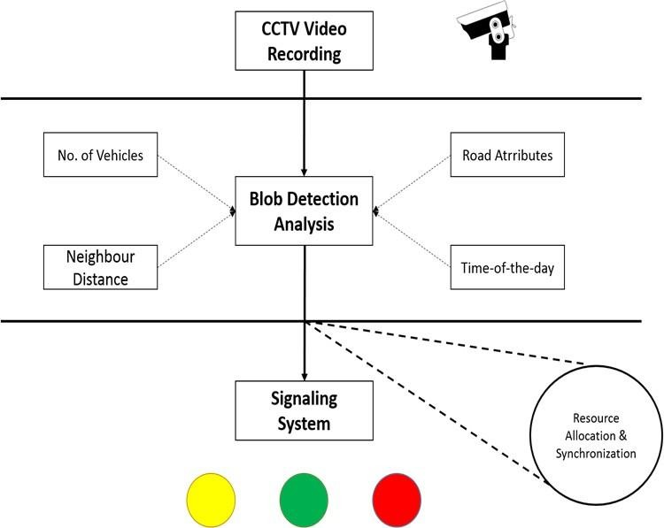

***Fig -1****: System Flow Diagram*

## Component Description

* *First priority goes to the welcome form. When admin will login the system there will be welcome screen whichwill assure to the use either admin wants to initiate the system or not.*
* *If the admin press Exit then the system should ask for authentication and reason for interruption (helps inanalysis later).*
* *If the admin presses Enter the system will proceed further and admin can set the cameras to be associatedwith it.*
* *The admin can perform the operations like configuring the CCTV cameras, format configuration, Image processor algorithm can also be modified but only before starting*

the system.

* *Once admin fixes the CCTVs, it should automatically start recording real time traffic and sending output to thesignal points.*
* *The timing of lights would be dependent on the traffics and length of it on all the four sides.*

# 3. EXTERNAL INTERFACE REQUIREMENTS

## User Interface

* *The design and layout of every form will be very clear and very interactive to the administrator.*
* *When the administrator opens the software, the welcomewindow will appear.*
* *From each and every window the user can easily go to any desired window so that there will be an absolute and relative linking and admin can monitor and track the process easily.*
* *There should be proper coordination between the different modules and that should also be maintained atthe front end in terms of look and feel to the DA.*
* *In the screen layout, the background color is very light and the graphics and font style will be in proper manner and well organized.*
* *The admin will be able to check out the logs anytime for identification of errors or lags in the system.*

## Software Interface

An external firewall can be attached to the application in order to prevent unauthorized access to the system. Also, a user authentication- Login system should be there to identify the System administrator.

## Communication Interfaces

Even the system administrator need not act as an interface. His/her only work would be to initiate the process. Afterwards, the management system takes over and it won’t stop unless stopped by an external force or system breakdown. Initiation would start from:

* *Add the chosen traffic CCTVs whose recording is to be done. Analyze those videos and the format configurationfor recording should be AVI format.*
* *Calculate timing information and give it to the signal systems.*

# 4. NON-FUNCTIONAL REQUIREMENTS

## Performance Requirements

* *The performance of the functions and every module must be well.*
* *The overall performance of the software will enable theusers to work efficiently.*
* *System should give better resource sharing results.*
* *Performance of the results and data application should beefficient and fast enough.*

## Security Requirements

Since, these systems affect the daily traffic population, the system should be secure enough and shouldn’t allow intruders to make changes or install bugs in it. Only System administrator should be authorized to access, modify, halt and carry out anyother functions.

# 5. WORKING OF ALGORITHM

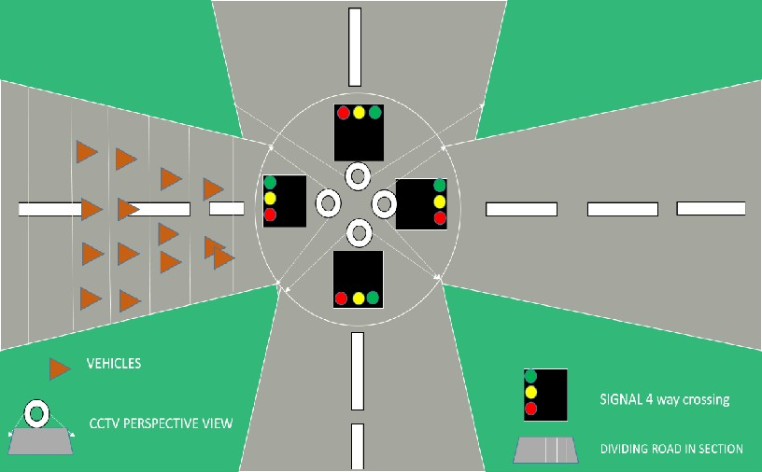

***Fig -2****: Architectural Diagram*

* *Analyzing the video footage received from the CCTV placed at signals on the highways/ freeways (4-way crossings).*
* *Analysis will be done using inbuilt OpenCV Libraries to extract the information from video footage.*
* *The information received from the footage will be used to know the length/stretch till*

which the vehicles are present by dividing the length into small sections.

* *The above calculation will be done for each CCTV footage, at each road of the 4-way crossing.*
* *The resource mentioned above is the section of the road which is needed for the vehicles on road A to go to roadB.*
* *Hence the problem reduces to 4 processes competing to share a resource which can be scheduled with the help of a job scheduling algorithm.*

The algorithm will work on various parameters in therun-time situation to produce an optimal result. Variousfactors/constraints are listed below, which will influence the allocation of the time interval for the road/lanes by

the signal using algorithm:

* *Length of the Traffic on the route, i.e., number of vehicles on the road,*
* *Distance between the Consecutive Signals,*
* *Synchronization among Consecutive Signals,*
* *Time-of-the-day,*
* *Dedicated Lanes, if available (for left turns)*

***6. CONCLUSIONS***

In this paper, we have proposed a solution to tackle the traffic congestion problem without human involvement i.e., anautomated dynamic system. This system involves taking snapshots as input from the CCTV cameras, processing of the images to extract vehicle density at each side of intersection,computation of timing slots for traffic lights.

The major advantage of this system is it’s dynamic and adaptive to the traffic flow density at any instant which makes it more reliable for traffic system applications. Other than that, a number of benefits can be extracted out of this system like minimal or zero human effort, easy driving, signal workings according to vehicle density, reduction in vehicle accidents, reducing waiting time which leads to less noise pollution and reduced fuel expenditure.

This system is applicable to both independent and dependent signals- since the computation focuses on number of vehicles, vehicle density, number of phase cycles, peak factor etc. The mentioned factors are independent of relation between two consecutive signals; thus, it acts as additional benefit.

Furthermore, the system has a scope for modification as the development is object-driven. In future, if we want to construct or develop a more complex system for handling complicated roads (like roads having diversions or side lanes), we can easily develop the complex system over our proposed system or use our system as a module for it.